IT24102326  
Dadallage.S  
Lab-08  
  
1. Calculate population mean and variance of the dataset.





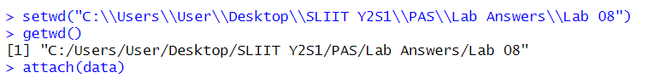





2. Get 30 random samples of size 5, with replacement and calculate sample mean and sample variance for each sample.



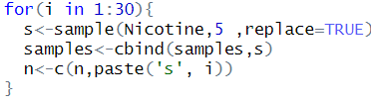

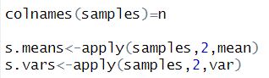

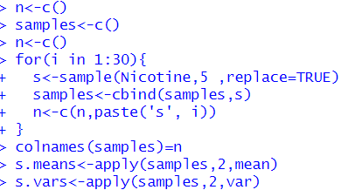

3. Calculate mean and variance of the Sample Means.





4. Compare and state relationship (if any) Population Mean and the Mean of Sample Means.





5. Compare and state relationship (if any) Population Variance and the Variance of Sample Means.



Exercise

1. Calculate the population mean and population standard deviation of the laptop bag weights.

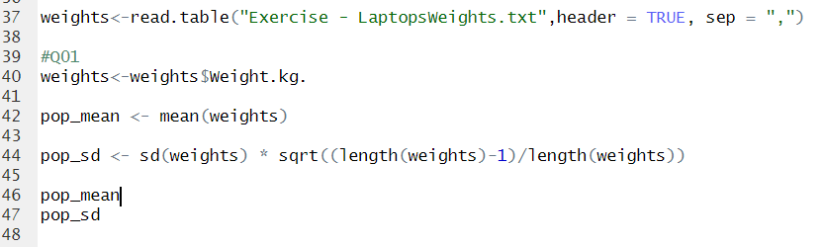

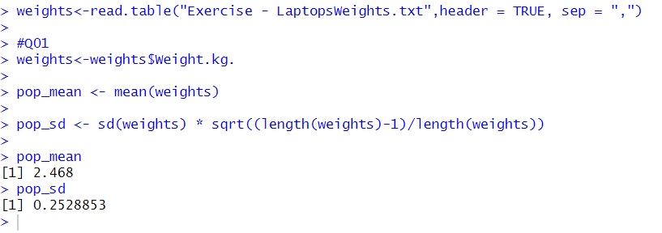

2. Draw 25 random samples of size 6 (with replacement) and calculate the sample mean and sample standard deviation for each sample.

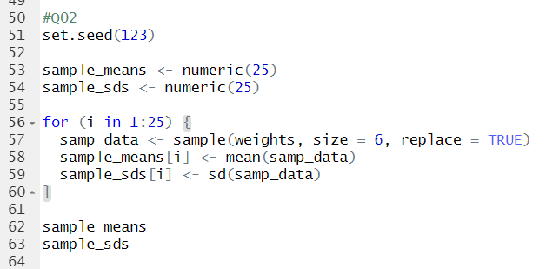

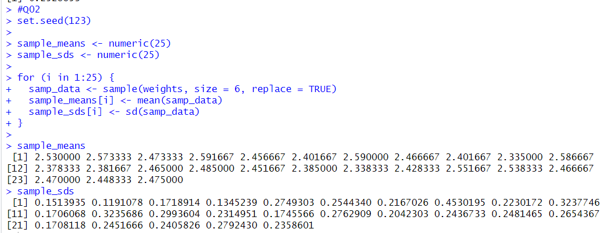

3. Calculate the mean and standard deviation of the 25 sample means and state the relationship of them with true mean and true standard deviation.

